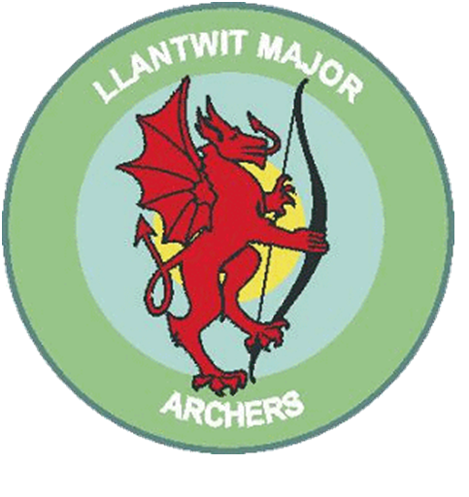
Llantwit Major Archery club

Adult Outdoor Fleece £15.00 each
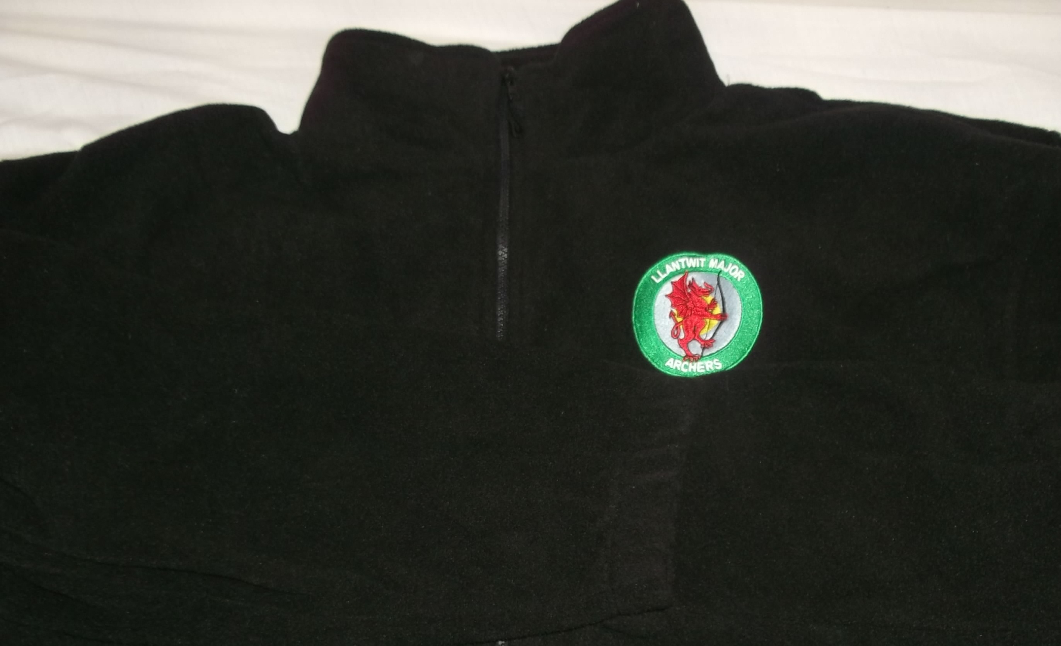
A quality 300gsm Fleece in black, complete with Llantwit Major Archers badge embroidered on the left chest.
Available is sizes XS – 7XL!
If you require a bigger size than listed please specify on your order form.

PLEASE ENSURE YOUR WRITING IS LEGIBLE!

Order name
Size | Quantity | Cost
XS
S
M
L
XL
2XL
3XL
 | Total

Please make cheques payable to Llantwit Major Archery Club

